[10/08/21]seed@VM:~/lab02$ grep -o a ciphertext.txt |wc -l

81

[10/08/21]seed@VM:~/lab02$ grep -o b ciphertext.txt |wc -l

1

[10/08/21]seed@VM:~/lab02$ grep -o c ciphertext.txt |wc -l

26

[10/08/21]seed@VM:~/lab02$ grep -o d ciphertext.txt |wc -l

7

[10/08/21]seed@VM:~/lab02$ grep -o e ciphertext.txt |wc -l

6

[10/08/21]seed@VM:~/lab02$ grep -o f ciphertext.txt |wc -l

64

[10/08/21]seed@VM:~/lab02$ grep -o g ciphertext.txt |wc -l

30

[10/08/21]seed@VM:~/lab02$ grep -o h ciphertext.txt |wc -l

45

[10/08/21]seed@VM:~/lab02$ grep -o i ciphertext.txt |wc -l

4

[10/08/21]seed@VM:~/lab02$ grep -o j ciphertext.txt |wc -l

16

[10/08/21]seed@VM:~/lab02$ grep -o k ciphertext.txt |wc -l

31

[10/08/21]seed@VM:~/lab02$ grep -o l ciphertext.txt |wc -l

85

[10/08/21]seed@VM:~/lab02$ grep -o m ciphertext.txt |wc -l

1

[10/08/21]seed@VM:~/lab02$ grep -o n ciphertext.txt |wc -l

18

[10/08/21]seed@VM:~/lab02$ grep -o o ciphertext.txt |wc -l

93

[10/08/21]seed@VM:~/lab02$ grep -o p ciphertext.txt |wc -l

116

[10/08/21]seed@VM:~/lab02$ grep -o q ciphertext.txt |wc -l

12

[10/08/21]seed@VM:~/lab02$ grep -o r ciphertext.txt |wc -l

0

[10/08/21]seed@VM:~/lab02$ grep -o s ciphertext.txt |wc -l

41

[10/08/21]seed@VM:~/lab02$ grep -o t ciphertext.txt |wc -l

0

[10/08/21]seed@VM:~/lab02$ grep -o u ciphertext.txt |wc -l

15

[10/08/21]seed@VM:~/lab02$ grep -o v ciphertext.txt |wc -l

26

[10/08/21]seed@VM:~/lab02$ grep -o w ciphertext.txt |wc -l

61

[10/08/21]seed@VM:~/lab02$ grep -o x ciphertext.txt |wc -l

35

[10/08/21]seed@VM:~/lab02$ grep -o y ciphertext.txt |wc -l

68

[10/08/21]seed@VM:~/lab02$ grep -o z ciphertext.txt |wc -l

79

[10/08/21]seed@VM:~/lab02$ grep -o ya ciphertext.txt |wc -l

7

[10/08/21]seed@VM:~/lab02$

## TASK2

[10/08/21]seed@VM:~/lab02$

[10/08/21]seed@VM:~/lab02$ openssl enc -aes-128-cbc -e -in plain.txt -out cipher.bin -K 00010203040506070809aabbccddeeff -iv 0a0b0c0d0e0f010203040506070809

[10/08/21]seed@VM:~/lab02$

[10/08/21]seed@VM:~/lab02$ xxd cipher.bin

00000000: e11f 1c04 5fb6 0146 b22f 3a51 e2f7 f491 ...._..F./:Q....

00000010: b895 bf2a 001f e24a ce1a 31f2 48e1 4ed9 ...*...J..1.H.N.

[10/08/21]seed@VM:~/lab02$

[10/08/21]seed@VM:~/lab02$

[10/08/21]seed@VM:~/lab02$

[10/08/21]seed@VM:~/lab02$ openssl enc -aes-128-cfb -e -in plain.txt -out cipher.bin -K 00010203040506070809aabbccddeeff -iv 0a0b0c0d0e0f010203040506070809

[10/08/21]seed@VM:~/lab02$

[10/08/21]seed@VM:~/lab02$ xxd cipher.bin

00000000: a4d9 ea90 48ea 2077 3773 2e40 7ca1 e99a ....H. w7s.@|...

00000010: 4784 920e eab6 45ee 2b78 5d G.....E.+x]

[10/08/21]seed@VM:~/lab02$

[10/08/21]seed@VM:~/lab02$

[10/08/21]seed@VM:~/lab02$ openssl enc -bf-cbc -e -in plain.txt -out cipher.bin -K 00010203040506070809aabbccddeeff -iv 0a0b0c0d0e0f010203040506070809

[10/08/21]seed@VM:~/lab02$

[10/08/21]seed@VM:~/lab02$ xxd cipher.bin

00000000: 80b5 1844 66a5 7798 99f2 a4f8 ebea c637 ...Df.w........7

00000010: 452f 2f18 28c8 229f b341 7e90 0a36 68f9 E//.(."..A~..6h.

[10/08/21]seed@VM:~/lab02$

[10/08/21]seed@VM:~/lab02$

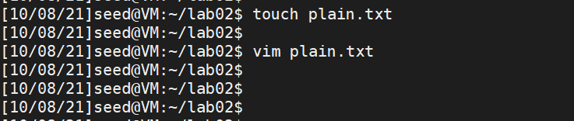

use three different cipher type, such as -aes-128-cbc , -aes-128-cfb , -bf-cbc ,

etc. In this task, you should try at least 3 di_erent ciphers and three di_erent mode

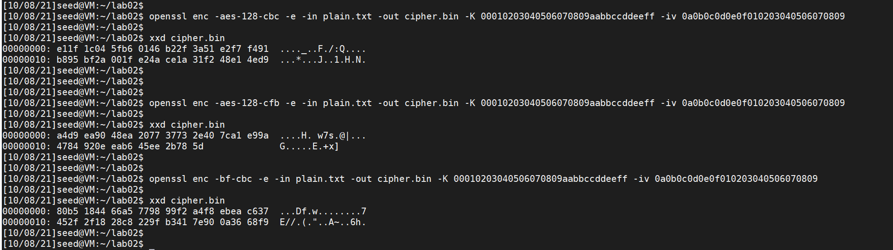

## TASK 3